**JDK, JRE, and JVM**

**JVM**

Java Virtual Machine – It’s a virtual machine which doesn’t exist physically, and help to execute the byte code.

Provides an environment for code execution.

JVM, JRE, and JDK are platform dependent because the configuration of each [OS](https://www.javatpoint.com/os-tutorial) is different from each other.

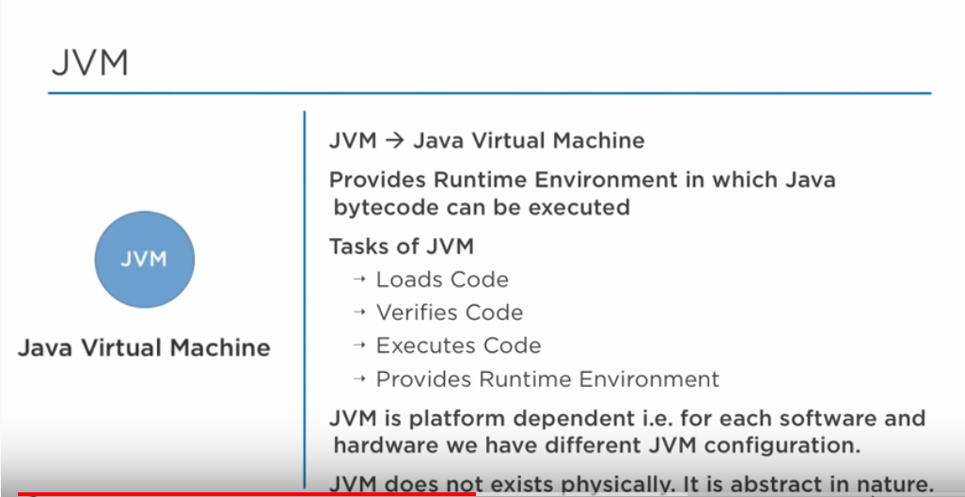

**JRE**

Java Runtime Environment (or can also be represented as Java RTE) – Combination of JVM and libraries set.

This libraries set is required by JVM at runtime for execution of code.

JRE helps to provide an environment for code execution.

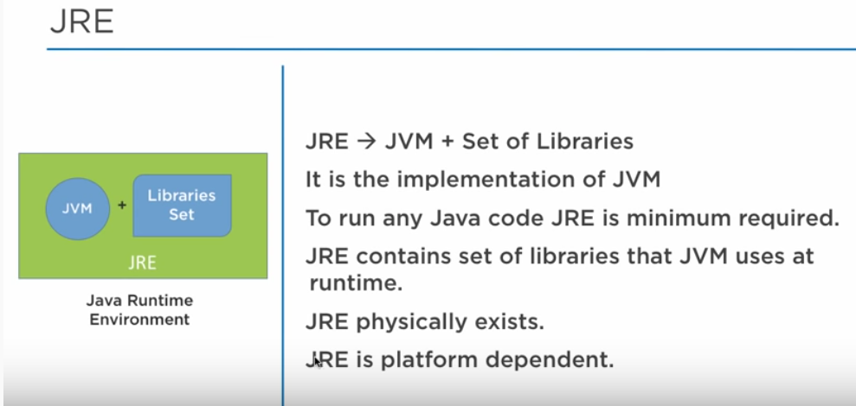

**JDK**

Java Development KIT – Combination of JRE and development tools.

JRE will only help to run the code, but for development any application or to write any program we need JDK.

Development tools includes executer, compiler, debugger and etc..

